Multi-Branch Project

Project Overview
- Create a simple Java Maven project.
- Version-control the project using Git with multiple branches.
- Set up Jenkins multi-branch pipeline for automated build and deployment.
- Utilize Jenkins environment variables in the Jenkinsfile.

Project Objectives
- Version-control using Git.
- Jenkins multi-branch pipeline setup.
- Environment variable management using Jenkinsfile.

Project Deliverables
- Git Repository:
  - Local Git repository initialized.
  - Branches: development, staging, and production.
  - Repository pushed to remote Git server (e.g., GitHub, GitLab, Bitbucket).

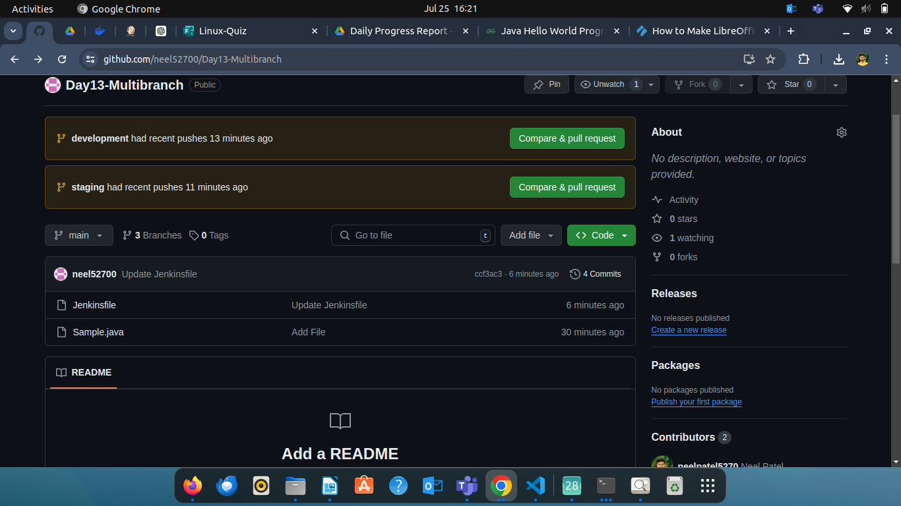
Step 1

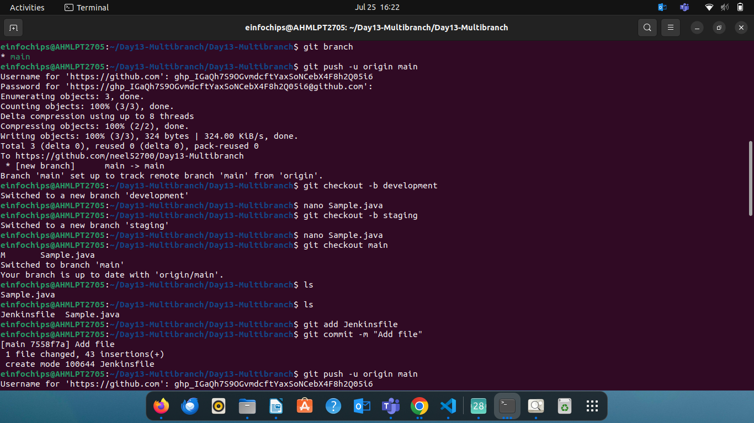

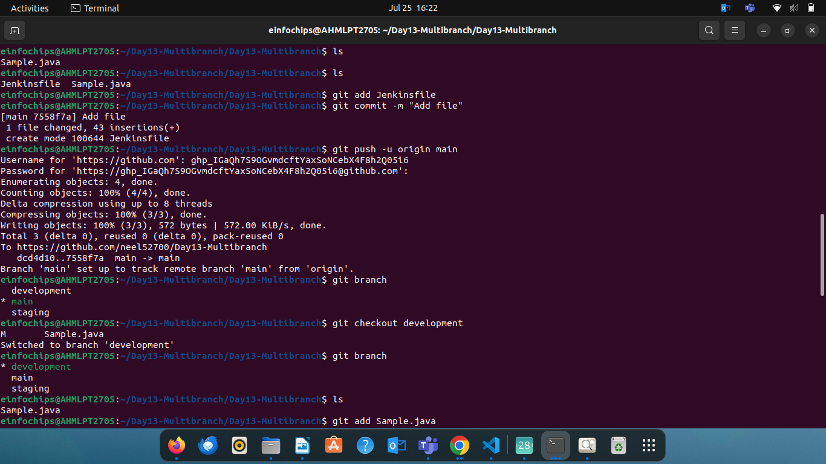

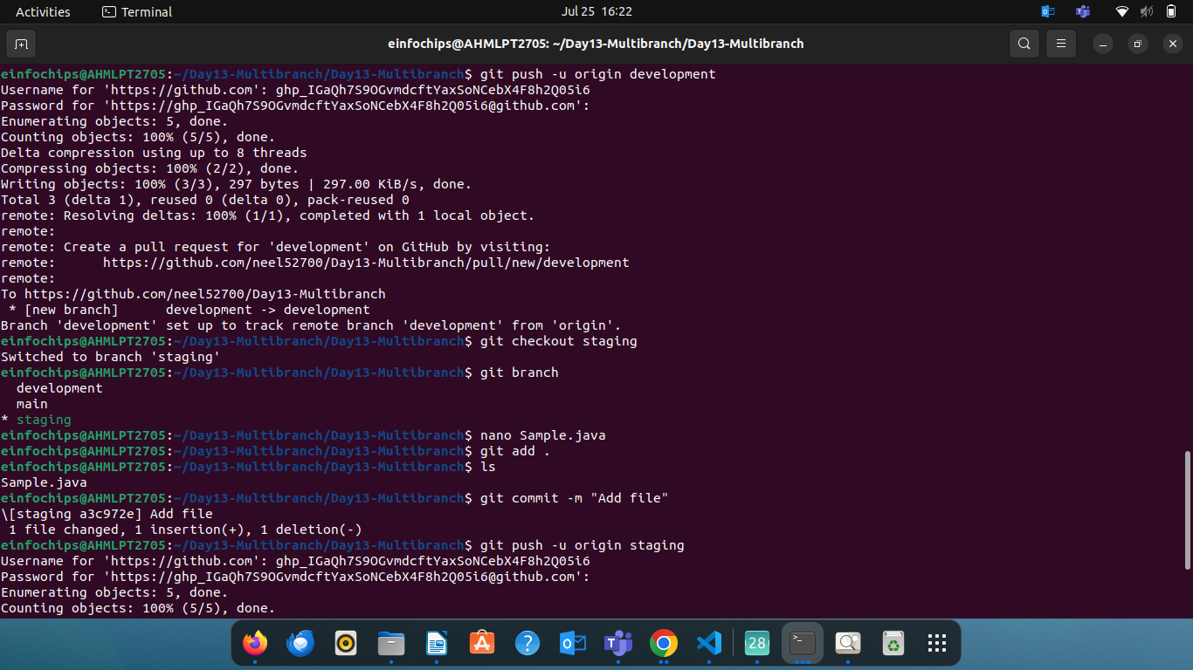

- Initialize Local Git Repository
- Create Branches
- Create a Simple Java Project on main branch
- Push to Remote Git Server
- Add the remote repository
- Push branches to the remote repository
- Create a jenkins file on main branch

- Maven Project:
  - Simple Java Maven project created (HelloWorld application).
  - pom.xml with dependencies and build configurations.

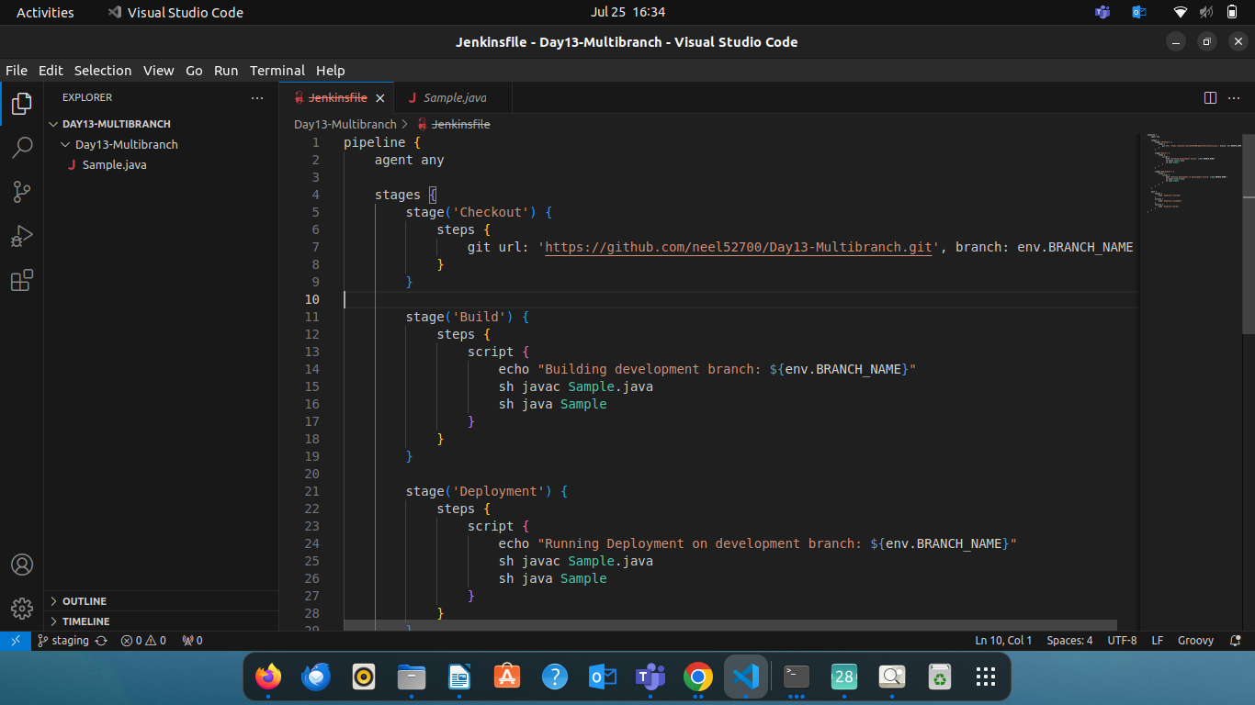

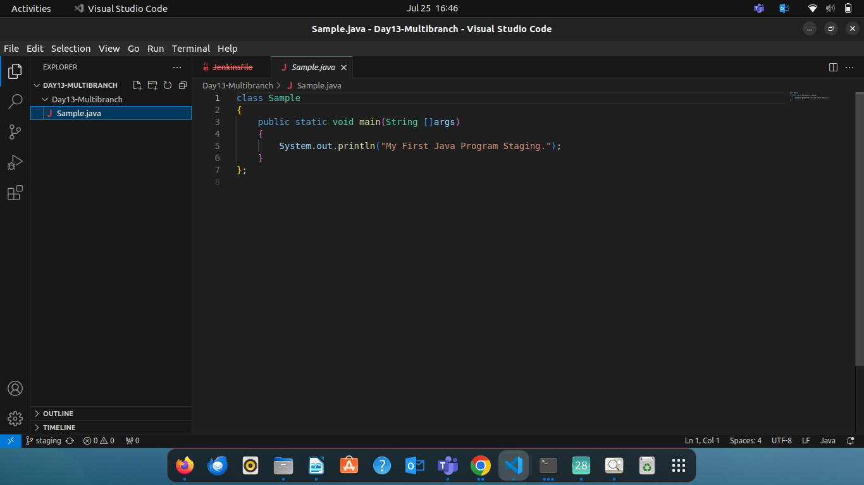

- Jenkins Setup:
  - Multi-branch pipeline job configured in Jenkins.
  - Jenkinsfile defining build and deployment steps.
  - Environment variables managed using Jenkins environment variable settings.

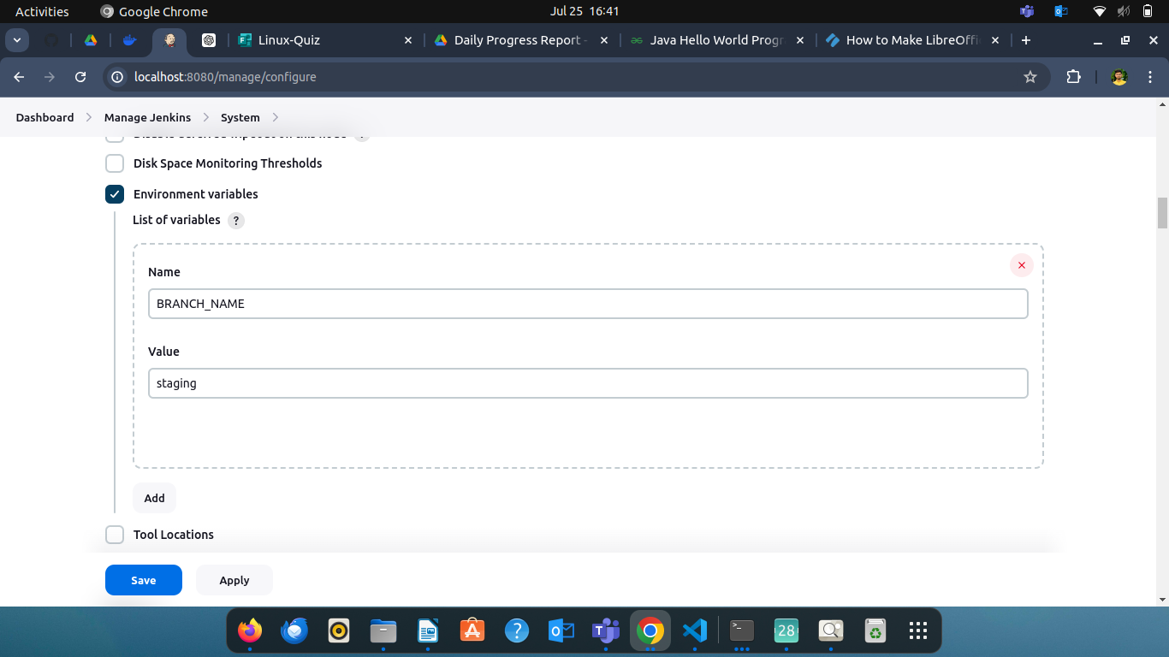

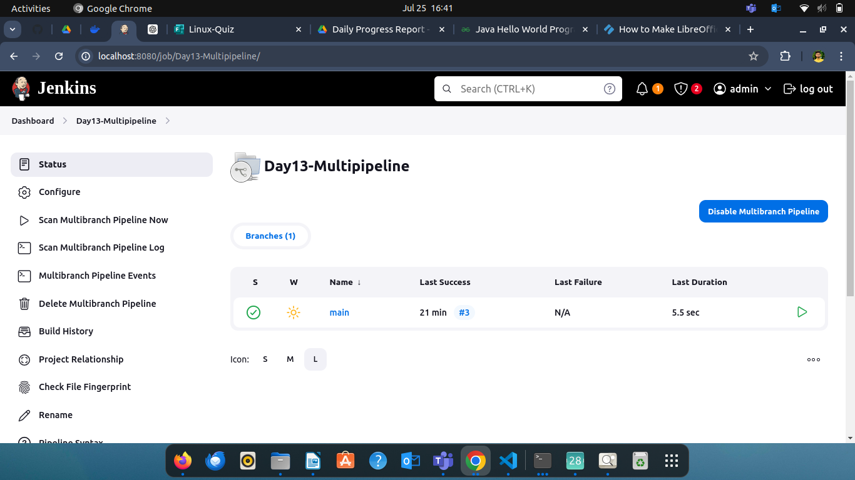

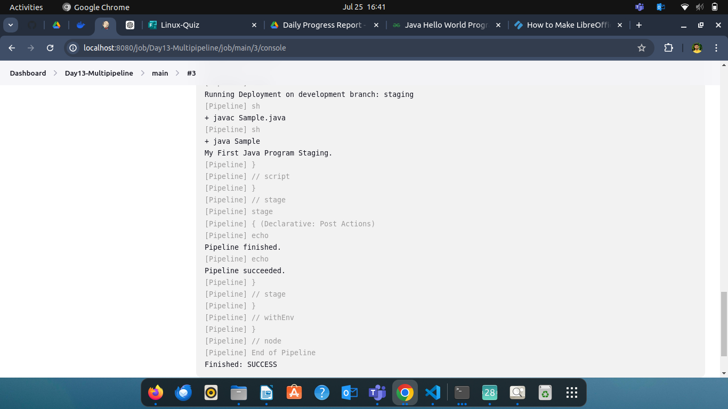

- Trigger the Pipeline Manually:
- Go to Jenkins dashboard.
- Select the pipeline job.
- Click on "Build Now".
- Monitor the Build Process:
  - Open the build details in Jenkins.
  - Check the console output to monitor the progress and status of each stage.

